Renault/Nissan Label Guideline
Label Structure

Version 1
9-Apr-19

Auteurs :
Jean-Claude BLANDIN
ALTRAN/Ousmane MAIGA

VER. | Date | AUTHOR | DESCRIPTIONS
 | (DD/MM/YY)
1.0 | 06/02/19 | Jean-Claude Blandin  ALTRAN/Ousmane MAIGA | Initial Release

Table of Contents
1. Introduction 5
1.1 Label description 5
1.2 What is the scope of the Label? 5
1.3 How are Labels created 5
1.4 Who defines the Label? 6
1.5 What is the Label File? 6
1.6 Process 6
1.7 Label life cycle 7
2. General Requirements 9
2.1 Functional Diagram 9
2.2 Data List, sorting & categorization 9
2.2.1 Label types 9
2.2.2 Label Description 10
2.2.3 Requirement 11
2.2.4 Variants 11
2.2.5 Variant link 12
3. Glossary 14
4. Annex 15

Purpose of the document

This document describes how the Labels and Label File are constructed.

This document’s scope is restricted to a technical description of the label file and its components. Its aim is to serve as a formal and centralized basis for discussing how tools can consume the Label resource.

This document isn’t a substitution to standard tool management documents such as AIA (or any other document) and should, therefor, not be treated as such.

Introduction

  - Label description

Diagnosis resources (ODX).
The After-sales scripts are managed by the After-Sales conceptor. When a script needs a Diagnosis resource the conceptor selects the Name of resource in the ODX Database.
During the execution of this script in the After-sales Diagnostic tool, the Runtime will search for the corresponding data to the resource’s name in the ODX the diagnosis command. If the name exists in the ODX data the script will receive the answer from the ECU, if the name doesn’t exist then the script will receive an error.
The name and description of the resources are managed by Ecu Designer. It could be possible that from one supplier to another one, one version of software to the next one, the names of resources can change.
It is the reason of the label file. This file contains a list of usable labels for one Software of ECU. Each Label contains the usable name in Script (Key) and the link to a resource existing in the ODX file. For each new Software it is needed to have a new Label file containing all the Labels (used in script) and all real links to ODX resources.
With the labels The Script managed by After sales contains only the name of label (managed by the conceptors). It can be identified as an After-Sales resource requirement. The Ecu Designer has to develop and find the equivalent resource for each requirement. It could be possible to have different links for different Ecu (software or supplier) for the same label name.

  - What is the scope of the Label?

Labels only cover resources identified by the After-Sales team. In other words, it refers to diagnostic resources visible in ADT Authoring Tool and ADT Runtime.
These resources refer to DTC, LID, DID, IR, RID, VP, RZ, etc...

  - How are Labels created

Step 1: The Label file firstly is created by the After-Sales conceptor with only the Description of all labels needed for one ECU (List labels ID, Names, Constraints, Conformities). At this step the label file doesn’t contain link to Resources.
Step 2: The Label file is sent to ECU Designer. The ECU designer has to update the label file by selecting for each Label the corresponding resource(s) found in the ECU description file (DDT Database); This DDT Database is the description of one software in one ECU.
Step 3: The Ecu Designer delivers the DDT Database and the Label file to be converted in ODX package. At this step, the convertors generate the ODX Database corresponding to DDT Database and Update the label file by adding the ODX Links for each label
Step 4: In case of multiple version of software of the ECU. A PDX Merger can merge all the Label files (One for each software) in one file containing all the description for each version. In this step the result will be one PDX containing All resources for all merged software and one label file containing all the links for the merged software.

  - Who defines the Label?

The implicated actors are:
SMD: List for each methods and scripts all the Needed of resources (Asking of labels)
Label Administrator: List Unique Key for label for All Ecus, All Resources
ECU Designer: Make the links between Asking labels and Contains Resources in the ECU
ODX Administrator: Validation/Check of the quality of the label file. Merge PDX and label File
AS “Conceptor”: Load PDX in Authoring tool and use Labels in Scripts.

  - What is the Label File?

The Label file is an XML file associate to the ODX-D file for one ECU (ODX-D). The Label file will be contained in the unitary engineering PDX File placed on the Engineering server. One Label file for one unitary PDX file.

  - Process

Fig 1. Label process

  - Label life cycle

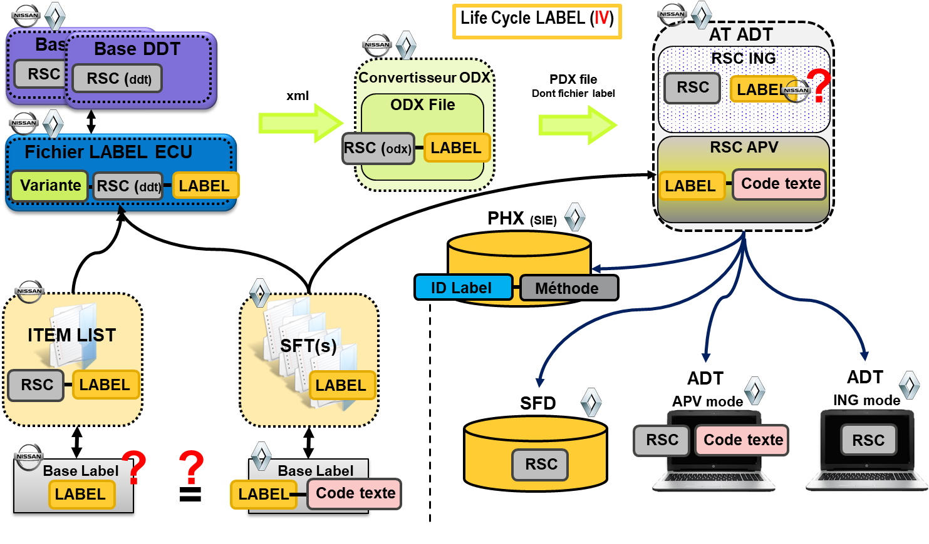
Fig 2. Label life cycle diagram

General Requirements

  - Functional Diagram
Fig 3. Label tree diagram
  - Data List, sorting & categorization

    - Label types
Label file contains blocs for Labels description.
Label Type | ### Type |  | XML Link Property
Readable Labels | Type6 | Links to Data(s) in DID (LID) | multiple DataLink SN=Parameter
Writable Labels | Type1 | Links to one Data in DID (if DID contains multiple Data Label Request Created) | one DataLink SN = Parameter
IO Labels | Type5 | 1: Links to one request without parameter | one RQLink SN = Struture
 |  | 2: Links to one DID without parameter | one RQLink SN = Structure
 |  | 3: Links to one DID with parameter | multiple DataLink SN=Parameter
Routine Labels | Type5 | 1 : Links to one request without parameter | one RQLink SN = Struture
 |  | 2: Links to one DID without parameter | one RQLink SN = Structure
 |  | 3 : Links to one DID with parameter | multiple DataLink SN=Parameter
Snapshot Labels | Type1 | Links to one Data in reading DID | one DataLink SN = Parameter
Extended labels | Type1 | Links to one Data in 1906 | one DataLink SN = Parameter
Fault Labels | Type3 | Links to DTC(s) (Device Number + Fault Type) | multiple DataLink SN = DTC-FT 3 Bytes
Script Labels | Type4 | Links to multiple requests without parameters | multiple RQLink SN = Structure
Request Labels | Type2 | Automatic generation to describe Request containing multiple Data | multiple DataLink SN = Parameter
Fig 3. Label type table (ADT view)

The labels can have 6 different Type of description depending of the type of links managed.
- Readable Labels (Type 6)
  - The label is link to one or multiple Data in the ODX file.
- Writable Labels (Type 1)
  - The Label is link to only one Data in the ODX file.
- IO Labels (Type 5)
  - The label is link to one request with or without Data in the ODX file.
Routine Labels (Type 5)
  - The label is link to one or multiple Data in the ODX File.
  - The label is link to one request without Data in the ODX file.
- Scripts Labels (Type 4)
  - The label is link to multiple requests without Data
- Snapshot Labels (Type 1)
  - The Label is link to only one Data in the ODX file.
- Extended labels (Type 1)
  - The Label is link to only one Data in the ODX file.
- Fault Labels (Type 3)
  - The label is link to one or multiple DTC/FT in the ODX file.
- Request Labels (Type2)
  - The label is link to an existing Writable Label
The Label is link to only one Data in the ODX file.

    - Label Description

This bloc is repeat for each label. It describes the ID Name (Identification Key) and a definition of the label. The definition of the label is generated by the Baselabel Administrator.
This Bloc contains
- One Bloc Requirement
- One Bloc Variants

    - Requirement

The Bloc Requirement contains the requirement ask by the Diagnosis department to access or repair this element (Label). For example, if the Label is a DTC, the Requirement can be a “Timing of activation” for this DTC. For a Readable, the requirement can be “Ignition ON”,
- Constraint description (Free text)
- Conformity description (Free text)

    - Variants

The Bloc Variants contains One or multiple blocs VariantLink. Each Bloc VariantLink correspond to an identification (Entry) in the ODX File. It could be possible that for one label the links, the format, the DTCs can be different on one VariantLink and on the other.
Example :
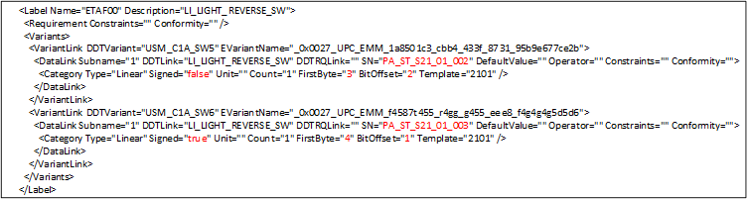
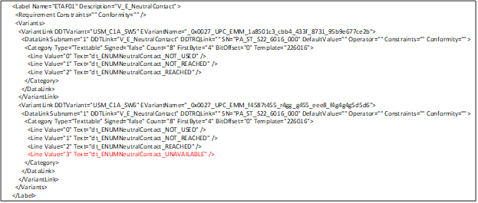

    - Variant link

- Variant for Label type 1 (Labels type Writable, Snapshot, Extended)
The Variant Link Part for Label type1 contains:
- The Name of the DDT Variant (Target name of the DDT Database) and the corresponding ECU Variant Name in the ODX
<VariantLink DDTVariant="USM_C1A_SW5" EVariantName="_0x0027_UPC_EMM_9f8a832f_bc43_43d0_b1fe_7d81227d45b7">
  - For each ECU Variant :
    - One and only one “DataLink” Element Containning :
      - Attribute “Subname” equal to “1”
      - Attribute “DDTLink” links to the DDT DataName (DataItem)
      - Attribute “DDTRQLink” Empty
      - Attribute “SN” links to the ODX Parameter ShortName
      - Attribute “DefaultValue” Empty
      - Attribute “Operator” Not used
      - Attribute “Constraints” Empty
      - Attribute “Conformity” Empty
      - One “Category” Element
        - Attribute “Type” containning the type of the data (Linear, Identical, Textable)
        - Attribute “Signed” present on Textable and Linear data type
        - Attribute “Unit” present on Textable and Linear data type and contains the DDT descritpion
        - Attribute “OdxUnitRef” present on Textable and Linear data type and contains the corresponding ODX unit
        - Attribute “Count” Size (DDTdescription) of the data
        - Attribute “FirstByte” Position (DDTdescription) of the data in the request
        - Attribute “BitOffset” Place (DDTdescription) of the data in the first byte
        - Attribute “Template” contains the 4 first Byte of the Request

- Variant for Label type 2 (labels Type Request)
The Variant Link Part for Label type2 contains:
- The Name of the DDT Variant (Target name of the DDT Database) and the corresponding ECU Variant Name in the ODX
<VariantLink DDTVariant="USM_C1A_SW5" EVariantName="_0x0027_UPC_EMM_9f8a832f_bc43_43d0_b1fe_7d81227d45b7">
  - For each ECU Variant :
    - One or more “DataLink” Element Containning :
      - Attribute “Subname” equal to the line number of the Datalink
      - Attribute “LabelLink” containning the Label Name describe in Writeable Element
      - Attribute “DDTLink” links to the DDT DataName (DataItem)
      - Attribute “DDTRQLink” Empty
      - Attribute “SN” links to the ODX Parameter ShortName
      - Attribute “DefaultValue” Empty
      - Attribute “Constraints” Empty
      - Attribute “Conformity” Empty
      - One “Category” Element
        - Attribute “Type” containning the type of the data (Linear, Identical, Textable)
        - Attribute “Signed” present on Textable and Linear data type
        - Attribute “Unit” present on Textable and Linear data type and contains the DDT descritpion
        - Attribute “OdxUnitRef” present on Textable and Linear data type and contains the corresponding ODX unit
        - Attribute “Count” Size (DDTdescription) of the data
        - Attribute “FirstByte” Position (DDTdescription) of the data in the request
        - Attribute “BitOffset” Place (DDTdescription) of the data in the first byte
        - Attribute “Template” contains the 4 first Byte of the Request
- Caution : If the LabelLink is empty, the attributes DDTLink, DDTRQLink, SN, have to be fill, If the labelLink is not empty and contains a name of LabelID the attributes DDTLink, DDTRQLink, SN will be empty because this information will be present this LabelID describe in Writeable Element

- Variant for Label type 3 (labels Type Fault)
The Variant Link Part for Label type3 contains:
- The Name of the DDT Variant (Target name of the DDT Database) and the corresponding ECU Variant Name in the ODX
<VariantLink DDTVariant="USM_C1A_SW5" EVariantName="_0x0027_UPC_EMM_9f8a832f_bc43_43d0_b1fe_7d81227d45b7">
  - For each ECU Variant :
    - One or more “DataLink” Element Containning :
      - Attribute “Subname” equal to the line number of the Datalink
      - Attribute “ID_DTC” containning DDT Device ID
      - Attribute “DTC_FT” containning DDT Fault Type
      - Attribute “DDTLink” containning the DDT Device name
      - Attribute “SN” links to the ODX DTC ShortName
      - Attribute “Constraints” Empty
      - Attribute “Conformity” Empty

- Variant for Label type 4 (labels Type Script)
The Variant Link Part for Label type 4 contains:
- The Name of the DDT Variant (Target name of the DDT Database) and the corresponding ECU Variant Name in the ODX
<VariantLink DDTVariant="USM_C1A_SW5" EVariantName="_0x0027_UPC_EMM_9f8a832f_bc43_43d0_b1fe_7d81227d45b7">
  - For each ECU Variant :
    - One or more “RQLink” Element Containning :
      - Attribute “Subname” equal to the line number of the RQLink
      - Attribute “DDTLink” Empty
      - Attribute “DDTRQLink” links to the DDT Request Name
      - Attribute “SN” links to the ODX Request ShortName
      - Attribute “Time” Containning the delay in ms

- Caution : In this type of labels, The request link to the SN cannot contains parameters. It must be hardcoded requests

- Variant for Label type 5 (labels Type Routines and IO)
The Variant Link Part for Label type 5 contains:
- The Name of the DDT Variant (Target name of the DDT Database) and the corresponding ECU Variant Name in the ODX
<VariantLink DDTVariant="USM_C1A_SW5" EVariantName="_0x0027_UPC_EMM_9f8a832f_bc43_43d0_b1fe_7d81227d45b7">
  - For each ECU Variant :
    - Choice of
      - One or more “DataLink” Element Containning :
        - Attribute “Subname” equal to the line number of the Datalink
        - Attribute “DDTLink” links to the DDT DataName (DataItem)
        - Attribute “DDTRQLink” Empty
        - Attribute “SN” links to the ODX Parameter ShortName
        - Attribute “DefaultValue” Empty
        - Attribute “Operator” Empty
        - Attribute “Constraints” Empty
        - Attribute “Conformity” Empty
        - One “Category” Element contains (Depending of the Type)
          - Attribute “Type” containning the type of the data (Linear, Identical, Textable)
          - Attribute “Signed” present on Textable and Linear data type
          - Attribute “Unit” present on Textable and Linear data type and contains the DDT descritpion
          - Attribute “OdxUnitRef” present on Textable and Linear data type and contains the corresponding ODX unit
          - Attribute “Count” Size (DDTdescription) of the data
          - Attribute “FirstByte” Position (DDTdescription) of the data in the request
          - Attribute “BitOffset” Place (DDTdescription) of the data in the first byte
          - Attribute “Template” contains the 4 first Byte of the Request
      - One and only one “RQLink” Element Containning :
        - Attribute “Subname” equal to the line number of the Datalink
        - Attribute “DDTLink” links to the DDT DataName (DataItem)
        - Attribute “DDTRQLink” Empty
        - Attribute “SN” links to the ODX Parameter ShortName
        - Attribute “DefaultValue” Empty
        - Attribute “Operator” Empty
        - Attribute “Constraints” Empty
        - Attribute “Conformity” Empty

- Caution : In case of DataLink, multiple Datalink can be present. In case of RQLink, Only one RQLink can be present

- Variant for Label type 6 (Labels type Readable)
The Variant Link Part for Label type1 contains:
- The Name of the DDT Variant (Target name of the DDT Database) and the corresponding ECU Variant Name in the ODX
<VariantLink DDTVariant="USM_C1A_SW5" EVariantName="_0x0027_UPC_EMM_9f8a832f_bc43_43d0_b1fe_7d81227d45b7">
  - For each ECU Variant :
    - One or more “DataLink” Element Containning :
      - Attribute “Subname” equal to “1”
      - Attribute “DDTLink” links to the DDT DataName (DataItem)
      - Attribute “DDTRQLink” Empty
      - Attribute “SN” links to the ODX Parameter ShortName
      - Attribute “DefaultValue” Empty
      - Attribute “Operator” Not used
      - Attribute “Constraints” Empty
      - Attribute “Conformity” Empty
      - One “Category” Element
          - Attribute “Type” containning the type of the data (Linear, Identical, Textable)
          - Attribute “Signed” present on Textable and Linear data type
          - Attribute “Unit” present on Textable and Linear data type and contains the DDT descritpion
          - Attribute “OdxUnitRef” present on Textable and Linear data type and contains the corresponding ODX unit
          - Attribute “Count” Size (DDTdescription) of the data
          - Attribute “FirstByte” Position (DDTdescription) of the data in the request
          - Attribute “BitOffset” Place (DDTdescription) of the data in the first byte
          - Attribute “Template” contains the 4 first Byte of the Request

Glossary

Term | Description
ADT | After-Sales Diagnostic Tool
APV | Or AFS designates After-Sales
DTC | DiagnosisTrouble Code
SFD | Diagnostic files server
SFT | System Failures Table

Annex

